**JS Code Sample References:** (source: https://pinetools.com/syntax-highlighter)

**Ir Black Xt 256**

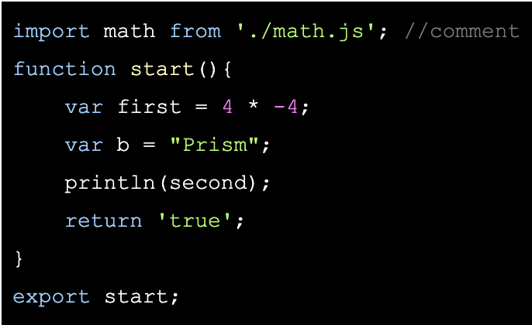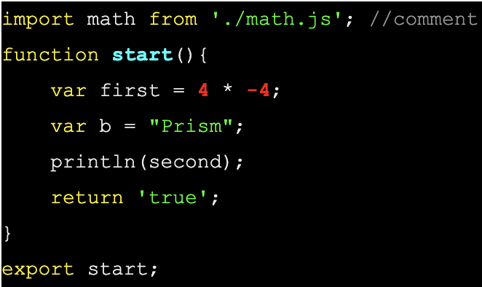

**Altier Dark Monokai Sublime**

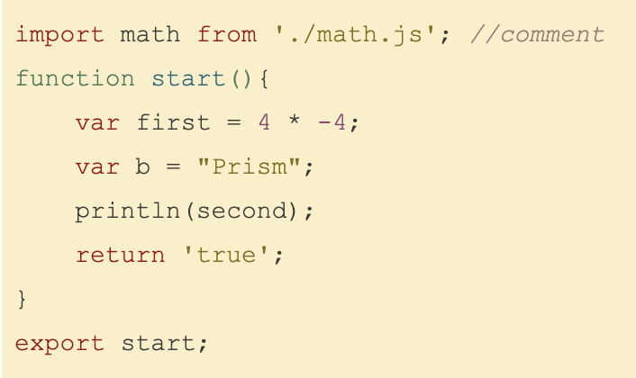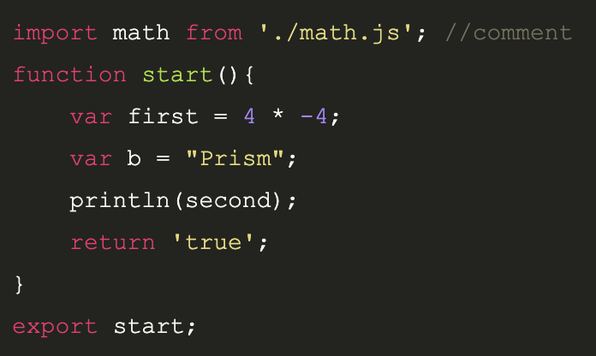

**Original Color Scheme (C++):**

#include <iostream>

#include <math.h>

using namespace std;

int main(){

double x = 2.3; //Comments

cout << “Hello there “ << sin(x) << endl;

return 0;

**JS Color Scheme:**

import math from './math.js'; //comment

function start(id){

var first = 4 * -4;

var b = "Prism";

println(second);

return 'true';

}

export start;

| **Color** | **JS Category** |
| --- | --- |
| #F6F6F6 (White) | Regular Text |
| #1E1E1F (Black) | Background |
| #CACCD2 (Light Gray) | Comments |
| #EA428F (Rose) | params |
| #E9402F (Red) | Numbers |
| #DFFD52 (Yellow) | Function Name |
| #AEFA4E (Lizard Green) | Chars/Strings |
| #74FBAF (Spring Green) | function |
| #66DDEF (Blue) | import, from, return, etc. |